A Project Report
on
VENUE BOOKING SYSTEM

Submitted in partial fulfillment of requirements for the award of the course
of
EGB1201-JAVA PROGRAMMING
Under the guidance of

Mrs.K.V. PRIYADHARSHINI M.E., (Ph. D).,
ASSISTANT PROFESSOR(IT)

Submitted By
PRIDEESWARI A (927624BEV031)

DEPARTMENT OF ELECTRONICS ENGINEERING VLSI(DESIGN AND TECHNOLOGY)

M.KUMARASAMY COLLEGE OF ENGINEERING
(Autonomous)
KARUR – 639 113
NOVEMBER 2025
i

M. KUMARASAMY COLLEGE OF ENGINEERING
(Autonomous Institution affiliated to Anna University, Chennai)

KARUR – 639 113

BONAFIDE CERTIFICATE

This is to certify that this project report on “VENUE BOOKING SYSTEM” is the bonafide work of PRIDEESWARI A (927624BEV031) who carried out the project work during the academic year 2025 - 2026 under my supervision.

SIGNATURE | SIGNATURE
Mrs.K.V. PRIYADHARSHINI M.E., (Ph. D).,  Assistant Professor/IT | Dr. N. MAHENDRAN M.E., Ph.D.,  HEAD OF THE DEPARTMENT
SUPERVISOR,  Department of Information Technology  M. Kumarasamy College of  Engineering,  Thalavapalayam, Karur -639 113. | Department of Electronics and  Communication Engineering,  M.Kumarasamy College of Engineering,  Thalavapalayam, Karur -639 113.

ii

INSTITUTION VISION AND MISSION

Vision
To produce highly skilled professionals and researchers in semiconductor
technology, driving innovation for next generation VLSI solutions.
Mission
M1: Impart quality education in VLSI technology that meets global standards.
M2: Promote research, innovation, and industry collaborations in emerging
semiconductor technologies.
M3: Enhance entrepreneurial skills, ethical responsibility, and a passion for lifelong
learning.
DEPARTMENT VISION, MISSION, PEO, PO AND PSO
Vision
To empower the Electronics and Communication Engineering students with emerging technologies, professionalism, innovative research and social responsibility.
Mission
M1: Attain the academic excellence through innovative teaching learning process, research areas & laboratories and Consultancy projects.
M2: Inculcate the students in problem solving and lifelong learning ability.
M3: Provide entrepreneurial skills and leadership qualities.
M4: Render the technical knowledge and skills of faculty members.
Program Educational Objectives
PEO 1: Graduates will establish a strong foundation in VLSI design principles,
semiconductor technologies, and electronic systems to meet industry standards.
PEO 2: Graduates will apply research -d riven approaches and innovative ideas to
develop sustainable solutions for real time challenges in the semiconductor domain.
iii

PEO 3: Graduates will exhibit effective leadership, teamwork and ethical decision -
making skills and, encage in lifelong learning to contribute to societal development.

Program Outcomes
PO 1: Engineering knowledge: Apply the knowledge of mathematics, science, engineering fundamentals, and an engineering specialization to the solution of complex engineering problems.
PO 2: Problem analysis: Identify, formulate, review research literature, and analyze complex engineering problems reaching substantiated conclusions using first principles of mathematics, natural sciences, and engineering sciences.
PO 3: Design/development of solutions: Design solutions for complex engineering problems and design system components or processes that meet the specified needs with appropriate consideration for the public health and safety, and the cultural, societal, and environmental considerations.
PO 4: Conduct investigations of complex problems: Use research-based knowledge and research methods including design of experiments, analysis and interpretation of data, and synthesis of the information to provide valid conclusions.
PO 5: Modern tool usage: Create, select, and apply appropriate techniques, resources, and modern engineering and IT tools including prediction and modeling to complex engineering activities with an understanding of the limitations.
PO 6: The engineer and society: Apply reasoning informed by the contextual
knowledge to assess societal, health, safety, legal and cultural issues and the consequent responsibilities relevant to the professional engineering practice.
PO 7: Environment and sustainability: Understand the impact of the professional engineering solutions in social and environmental contexts, and demonstrate the
knowledge of, and need for sustainable development.
iv

PO 8: Ethics: Apply ethical principles and commit to professional ethics and responsibilities and norms of the engineering practice.
PO 9: Individual and team work: Function effectively as an individual, and as a member or leader in diverse teams, and in multidisciplinary settings.
PO 10: Communication: Communicate effectively on complex engineering activities with the engineering community and with society at large, such as, being able to comprehend and write effective reports and design documentation, make effective presentations, and give and receive clear instructions.
PO 11: Project management and finance: Demonstrate knowledge and understanding of the engineering and management principles and apply these to one’s own work, as a member and leader in a team, to manage projects and in multidisciplinary environments.
PO12: Life-long learning: Recognize the need for, and have the preparation and ability to engage in independent and life-long learning in the broadest context of technological change.
Program Specific Outcomes
PSO1: Applying knowledge in various areas, like Electronics, Communications, Signal processing, VLSI, Embedded systems etc., in the design and implementation of Engineering application.
PSO2: Able to solve complex problems in Electronics and Communication
Engineering with analytical and managerial skills either independently or in team using latest hardware and software tools to fulfil the industrial expectations.

v

ABSTRACT
The Venue Booking System is a Java-based application designed to simplify the process of reserving venues for various events such as weddings, conferences, parties, and meetings. The main objective of this system is to provide an efficient, user-friendly, and digital platform that replaces traditional manual booking methods.This system allows users to browse available venues, view details such as location, capacity, and cost, and book them conveniently through an interactive interface. The application also provides secure user registration and login features for customers and administrators. The admin module enables the administrator to manage venue details, add or update venue information, and view booking requests made by customers.The project is developed using Java for the backend logic, HTML/CSS/JavaScript for the frontend interface (if web-based), and MySQL as the database for storing user and booking information. It ensures data accuracy, real-time availability, and transparency between customers and the management team.Overall, the Venue Booking System aims to automate venue management, reduce booking time, eliminate double-booking errors, and provide a seamless experience for both customers and administrators

Vi

ABSTRACT WITH POs AND PSOs MAPPING
ABSTRACT | COs MAPPED | POs MAPPED | PSOs MAPPED
The Venue Booking System is a Java-based application designed to simplify the process of reserving venues for various events such as weddings, conferences, parties, and meetings. The main objective of this system is to provide an efficient, user-friendly, and digital platform that replaces traditional manual booking methods.This system allows users to browse available venues, view details such as location, capacity, and cost, and book them conveniently through an interactive interface. The application also provides secure user registration and login features for customers and administrators. The admin module enables the administrator to manage venue details, add or update venue information, and view booking requests made by customers.The project is developed using Java for the backend logic, HTML/CSS/JavaScript for the frontend interface (if web-based), and MySQL as the database for storing user and booking information. | CO1  CO2  CO3  CO4  CO5 | PO1  PO2  PO3  PO4  PO5  PO6  PO7  PO8  PO9  PO10  PO11  PO12 | PSO(1) PSO(2)  PSO(3)

SUPERVISOR HEAD OF THE DEPARTMENT
vii

TABLE OF CONTENTS

CHAPTER  No. | TITLE | PAGE  No.
 | ABSTRACT
1 | INTRODUCTION
 | 1.1 OBJECTIVE | 1
 | 1.2 OVERVIEW | 1
 | 1.3 JAVA PROGRAMMING CONCEPTS | 2
2 | PROJECT METHODOLOGY | 4
 | 2.1 PROPOSED WORK | 4
 | 2.2 ARCHITECTURE | 5
3 | SOFTWARE REQUIREMENTS | 7
4 | MODULE DESCRIPTION | 8
 | 4.1 USER MANAGEMENT | 8
 | 4.2 VENUE MANAGEMENT | 9
 | 4.3 SEARCH & BOOKING | 9
 | 4.4 PAYMENT MODULE | 10
 | 4.5 ADMIN PANEL | 10
5 | RESULTS AND DISCUSSION | 11
6 | CONCLUSION | 15
 | REFERENCES | 16
 | APPENDIX | 17

viii

CHAPTER 1

INTRODUCTION

OBJECTIVE

The main objective of the Venue Booking System is to develop an efficient, user-friendly, and automated platform that simplifies the process of booking venues for various events such as weddings, meetings, conferences, and parties. This project aims to eliminate the problems associated with traditional manual booking systems, such as data inaccuracy, time consumption, and lack of transparency. The system enables users to register, log in, browse available venues, and book halls easily through an interactive interface. It also provides an administrator module that allows the admin to manage venue details, update event information, and handle booking requests effectively. The system ensures secure storage of user and booking data using a database connection, thereby reducing errors and improving data accuracy. Overall, the objective of the Venue Booking System is to create a convenient, reliable, and secure online platform that enhances customer satisfaction and simplifies the venue management process for both users and administrators.

OVERVIEW

The Venue Booking System is a Java-based application developed to automate and streamline the process of booking event halls for various occasions such as weddings, parties, meetings, and conferences. In traditional methods, customers often have to visit venues personally or contact managers by phone, which is time-consuming and prone to errors. This project provides a digital solution where users can easily browse available venues, view their details such as location, capacity, and

cost, and make bookings directly through the system. It also allows the administrator to manage venue information, update hall details, monitor bookings, and maintain customer records efficiently. The system ensures data accuracy, real-time availability, and secure access for both customers and the admin. By integrating technologies such as Java, HTML, CSS, JavaScript, and MySQL, the system delivers an interactive interface and a reliable backend. Overall, the Venue Booking System aims to provide a complete and convenient platform that improves the booking experience, reduces manual effort, and enhances the overall management of event venues.

1.3 JAVA PROGRAMMING CONCEPTS
- OOP Concepts (Object-Oriented Programming)
- Classes & Objects: Classes like User, Venue, and Booking are created to represent real-world entities
- Inheritance: Common features are shared through parent and child classes (e.g., Admin and Customer extend User).
- Polymorphism: Methods like calculatePrice() behave differently for different types of bookings.
- Encapsulation: User and booking data are secured using private variables and public getter/setter methods.
- Collections Framework
- ArrayList and HashMap are used to store and manage users, venues, and booking details efficiently.

- Exception Handling
- Try-catch blocks are used to handle invalid inputs, login errors, and booking conflicts gracefully.
- JDBC (Java Database Connectivity)
- JDBC is used to connect Java with the MySQL database for managing users, venues, and booking transactions.
- Abstraction
- Interfaces are used for defining payment methods.
- Abstract classes are used for defining base booking functionality.
- GUI (Swing)
- A user-friendly graphical interface is designed for booking venues, displaying halls, and managing user data.
- I/O Streams
- Input and Output Streams handle data reading and writing operations such as saving booking receipts or logs
- Packages
- The code is divided into packages (e.g., user, venue, booking, admin) for better structure, readability, and maintenance.

CHAPTER 2
PROJECT METHODOLOGY

2.PROPOSED WORK
The proposed work for the Venue Booking System focuses on developing a computerized platform that simplifies and automates the process of booking venues for various events such as weddings, meetings, and parties. The system aims to overcome the drawbacks of manual booking methods by providing an online interface where users can easily register, log in, view available venues, and make bookings efficiently. It also allows the administrator to manage all venue-related activities such as adding new halls, updating details, and viewing booking requests. The proposed system ensures data accuracy, transparency, and faster operations through the integration of Java programming and a MySQL database. Exception handling, object-oriented principles, and JDBC connectivity are used to make the system reliable and secure. A graphical interface using Java Swing or JavaFX is designed to enhance user interaction. Overall, the proposed work focuses on creating a complete and user-friendly venue booking solution that saves time, reduces manual effort, and improves management efficiency for both users and administrators.

2.2ARCHITECTURE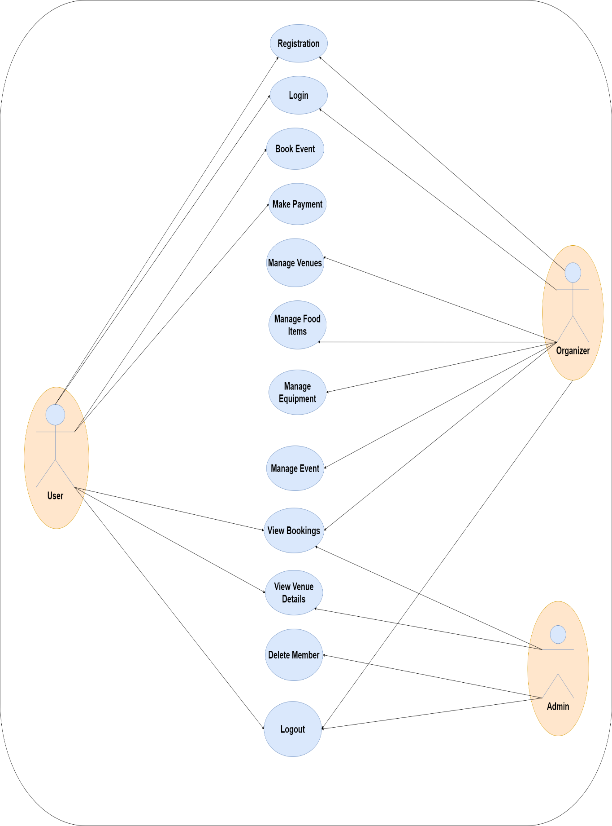

DESCRIPTION:

1. User
- The User is the customer who books events. Their main actions include:
- Registration – Create a new account.
- Login – Access their account securely.
- Book Event – Select a venue, event type, and book the event.
- Make Payment – Pay for the booked event.
- View Venue Details – Check available venues and facilities.
- View Bookings – See their event history and upcoming bookings.
- Logout – Safely exit the system.

2. Organizer
- The Organizer manages all event-related resources. Their functions are:
- Manage Venues – Add or edit venues.
- Manage Food Items – Handle catering options.
- Manage Equipment – Maintain items like sound systems and decorations
- Manage Event – Set event categories and details
- View Bookings – Check user bookings to prepare arrangements.
- Logout – Exit the system.

3. Admin
- Login
- View Venue Details
- Delete Member
- Logout

CHAPTER 3

SOFTWARE REQUIREMENTS
The Venue Booking System requires specific software components to ensure smooth development, execution, and maintenance of the project. The system is developed using Java as the main programming language, which provides platform independence and object-oriented features. The frontend is designed using HTML, CSS, and JavaScript to create an attractive and interactive interface, while the backend is handled using Java along with JDBC for database connectivity. MySQL is used as the database management system to store and retrieve user, venue, and booking information efficiently.
The project is implemented in an Integrated Development Environment (IDE) such as Visual Studio Code or NetBeans, which supports Java development and provides tools for debugging and testing. A web browser such as Google Chrome or Microsoft Edge is required to view and test the interface when using web-based components. For database management, MySQL Workbench or XAMPP can be used to manage and monitor database operations. The operating system recommended for running the system is Windows 10 or higher.
Overall, the software requirements include Java Development Kit (JDK 8 or above), Visual Studio Code or NetBeans IDE, MySQL database, and a web browser for testing and user interface display. These software tools collectively support the development, execution, and management of the Venue Booking System efficiently

CHAPTER 4
MODULE DESCRIPTION

4.1 USER MANAGEMENTMODULE
The User Management Module handles all activities related to users of the Venue Booking System. It allows new users to register by providing their personal details and login credentials. Existing users can log in securely to access their dashboard, view available venues, and make bookings. The module also enables users to update their profiles, change passwords, and view their booking history. On the admin side, this module helps in managing user accounts, verifying registrations, and removing inactive or duplicate users. It ensures secure authentication, data privacy, and smooth interaction between users and the system.

4.2 VENUE MANAGEMENT MODULE
The Venue Management Module is responsible for managing all information related to event venues in the system. It allows the administrator to add new venues, update existing details, upload pictures, and remove venues that are no longer available. Each venue record includes details such as name, location, capacity, price, and contact information. This module also helps in displaying venue details to customers so they can choose based on their preferences. It ensures that all venue data remains accurate, up to date, and easily accessible. Overall, this module plays a key role in maintaining the quality and reliability of venue information in the system.

4.3 SEARCH & BOOKING MODULE
The Search and Booking Module is a key component of the Venue Booking System that allows users to easily find and reserve venues based on their preferences and event requirements. Users can search for venues using filters such as location, capacity, date, and event type. The system displays a list of available venues with details like name, price, images, and contact information. Once a suitable venue is found, users can proceed to book it by entering event details such as date, time, and specific requirements. The module checks the availability of venues in real time to avoid scheduling conflicts and validates all booking information before confirming the reservation. After booking, a confirmation is generated and displayed in the user’s dashboard for future reference. The administrator can also view, approve, or manage bookings from the admin panel. This module ensures efficient and accurate venue management by automating the search and booking process, providing a smooth user experience, and reducing manual effort for both users and administrators.

4.4 PAYMENT MODULE
The Payment Module is an essential part of the Venue Booking System that handles all financial transactions securely and efficiently. It allows users to make payments for their booked venues through various payment methods such as credit or debit cards, UPI, or online banking. Once a user confirms a booking, the module calculates the total amount based on venue cost and applicable discounts or offers. It then processes the payment and generates an electronic receipt for the user. The module ensures secure transactions using encryption techniques and validates payment details to prevent errors or fraud. Administrators can track all payment records, view transaction histories, and manage refunds or cancellations if required. This module not only simplifies the payment process for users but also ensures

transparency and reliability in financial operations, making the overall booking experience more convenient and trustworthy.

4.5 ADMIN PANEL MODULE
The Admin Panel Module is the control center of the Venue Booking System that allows the administrator to manage and monitor all activities within the system. Through this module, the admin can add, update, or delete venue details, including venue name, location, capacity, images, and pricing information. It also enables the admin to view and manage user registrations, booking requests, and payment records. The admin can approve or reject bookings based on availability and check real-time updates on venue status. This module also provides the ability to manage feedback, promotional offers, and discount details. The admin dashboard offers an organized and user-friendly interface to oversee system operations efficiently. Overall, the Admin Panel Module ensures proper control, smooth operation, and effective management of the entire Venue Booking System by maintaining data integrity and supporting decision-making through clear and accessible information.

CHAPTER 5

RESULTS AND DISCUSSION
5.1 RESULT
5.1.1 STARTING PAGE:


5.1.2 LOGIN PAGE
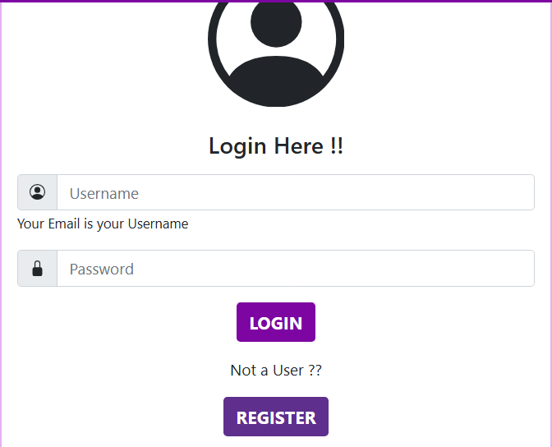

5.1.3 HOME PAGE
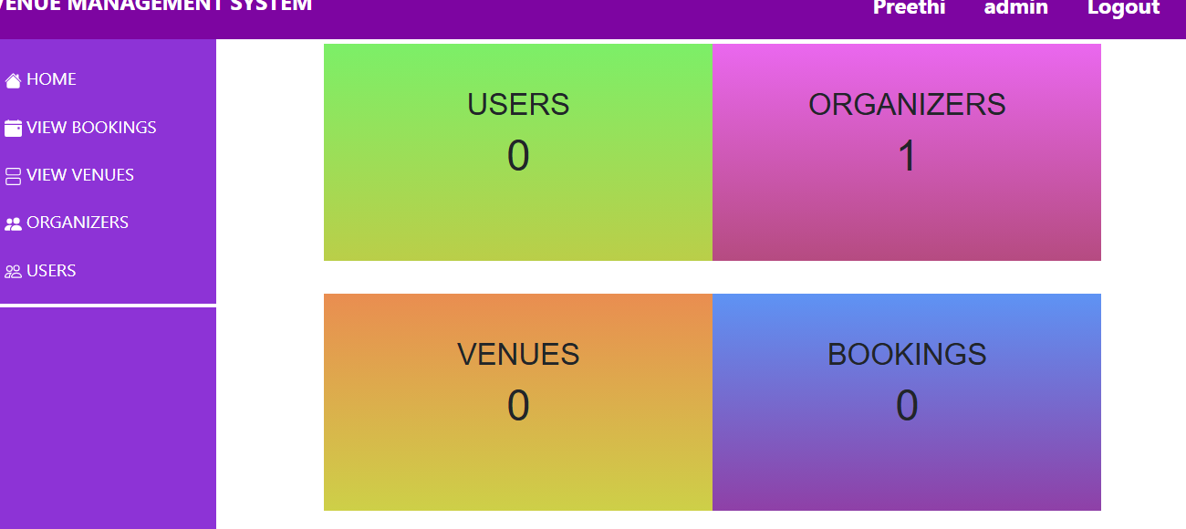

5.1.4 USER PAGE

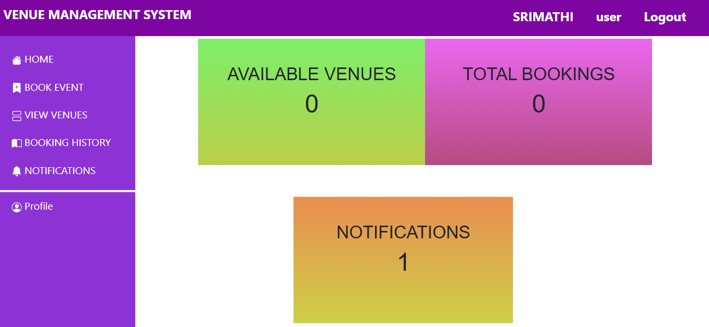

5.1.5 BOOKING PAGE

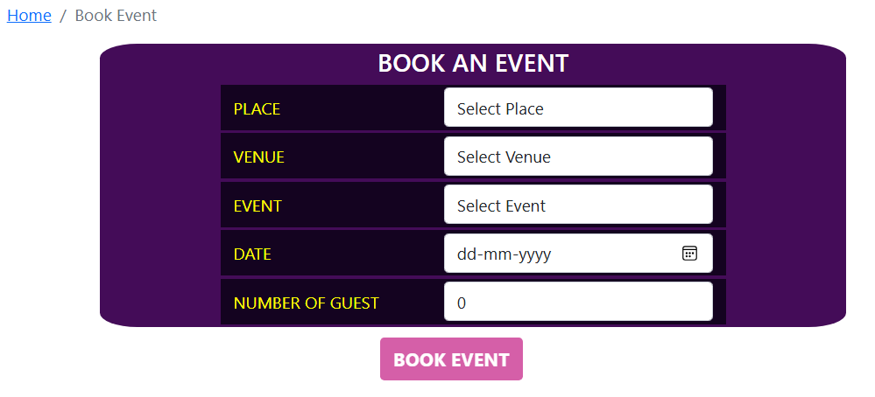
5.1.6 NOTIFICATION PAGE:
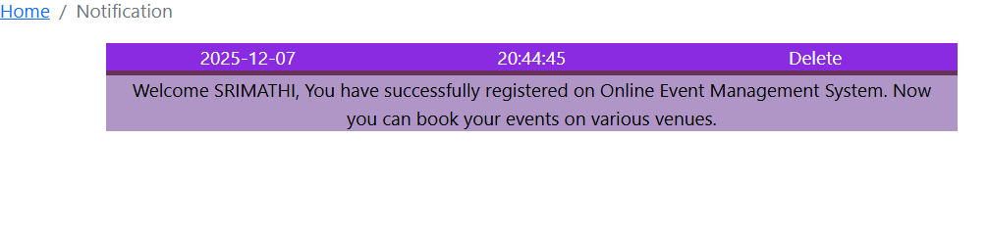
5.2 DISCUSSION

The discussion of the Venue Booking System focuses on how the system effectively addresses the challenges of traditional manual booking methods by providing an automated, user-friendly, and efficient digital platform. Through this project, users can easily browse available venues, check details such as location, capacity, and pricing, and make bookings in just a few clicks. The system uses Java for core

functionality, with HTML, CSS, and JavaScript for interface design, and MySQL for storing venue and user data securely. By integrating modules such as user management, venue management, booking, payment, and admin control, the system ensures smooth coordination between customers and administrators.

Exception handling, data validation, and secure payment mechanisms enhance system reliability and user trust. The use of object-oriented principles makes the system modular, flexible, and easy to maintain. Administrators can efficiently manage bookings, track payments, and update venue details, while users benefit from quick and transparent booking processes. Overall, the Venue Booking System successfully demonstrates how technology can simplify event management by saving time, reducing human errors, and providing a convenient solution for both customers and venue administrators.

CHAPTER 6

CONCLUSION

The Venue Booking System is a comprehensive and efficient platform designed to simplify the process of booking venues for various events such as weddings, meetings, and parties. It allows users to register, search for available venues, view detailed information, and complete bookings with secure online payments. The administrator can easily manage venue listings, monitor bookings, update information, and handle user feedback through the admin panel. The system ensures accuracy, transparency, and convenience by reducing manual errors and saving time for both users and administrators. It is developed using Java, HTML, CSS, JavaScript, and MySQL, making it reliable, scalable, and easy to maintain. Overall, the Venue Booking System provides a modern, user-friendly, and automated solution that enhances the event management experience and improves operational efficiency

REFERENCES

- Laudon, K. C., & Laudon, J. P. (2019). Management Information Systems: Managing the Digital Firm. Pearson Education.
- Sommerville, I. (2016). Software Engineering (10th ed.). Pearson.
- Pressman, R. S., & Maxim, B. R. (2015). Software Engineering: A Practitioner’s Approach (8th ed.). McGraw-Hill.
- Shelly, G. B., Rosenblatt, H. J., & Systems Analysis and Design Team. (2012). Systems Analysis and Design. Course Technology.
- Schwalbe, K. (2015). Information Technology Project Management (8th ed.). Cengage Learning.
- Stair, R., & Reynolds, G. (2017). Principles of Information Systems. Cengage.
- O’Brien, J. A., & Marakas, G. M. (2019). Introduction to Information Systems. McGraw-Hill.
- Turban, E., Volonino, L., & Wood, G. (2015). Information Technology for Management: Advancing Sustainable, Profitable Business Growth. Wiley.
- Dix, A., Finlay, J., Abowd, G., & Beale, R. (2004). Human-Computer Interaction. Pearson Education.
- Dennis, A., Wixom, B. H., & Roth, R. M. (2015). Systems Analysis and Design (6th ed.). Wiley.

APPENDIX

package com.management.Event.model;

import java.sql.Date;

import javax.persistence.Entity;
import javax.persistence.GeneratedValue;
import javax.persistence.GenerationType;
import javax.persistence.Id;
import javax.persistence.ManyToOne;
import javax.persistence.Transient;

@Entity
public class Booking {

@Id
@GeneratedValue(strategy = GenerationType.IDENTITY)
private int bookingId;
private Date date;
private int guestCount;
private String eventName;
private String equipmentName;
private String foodItemName;
private int eventCost;
private int equipmentCost;
private int foodItemCost;
private int totalCost;
private String paymentStatus;
@ManyToOne
private Member member;
@ManyToOne
private Venue venue;
@Transient
private int venueId;
@Transient
private int memberId;

public int getMemberId() {
return memberId;
}

public void setMemberId(int memberId) {
this.memberId = memberId;
}

public int getVenueId() {
return venueId;
}

public void setVenueId(int venueId) {
this.venueId = venueId;
}
private String selectedFoodItems;
private String selectedEquipments;
private int delStatus ;

public Booking() {
super();
}

public Booking(int bookingId, Date date, int guestCount, String eventName, String equipmentName,
String foodItemName, int eventCost, int equipmentCost, int foodItemCost, int totalCost,
String paymentStatus, Member member, Venue venue, String selectedFoodItems, String selectedEquipments) {
super();
this.bookingId = bookingId;
this.date = date;
this.guestCount = guestCount;
this.eventName = eventName;
this.equipmentName = equipmentName;
this.foodItemName = foodItemName;
this.eventCost = eventCost;
this.equipmentCost = equipmentCost;
this.foodItemCost = foodItemCost;
this.totalCost = totalCost;
this.paymentStatus = paymentStatus;
this.member = member;
this.venue = venue;
this.selectedFoodItems = selectedFoodItems;
this.selectedEquipments = selectedEquipments;
}

public int getDelStatus() {
return delStatus;
}
public void setDelStatus(int delStatus) {
this.delStatus = delStatus;
}
public int getBookingId(){
return bookingId;
}
public void setBookingId(int bookingId) {
this.bookingId = bookingId;
}
public Date getDate() {
return date;
}
public void setDate(Date date) {
this.date = date;
}
public int getGuestCount() {
return guestCount;
}
public void setGuestCount(int guestCount) {
this.guestCount = guestCount;
}
public String getEventName() {
return eventName;
}
public void setEventName(String eventName) {
this.eventName = eventName;
}
public String getEquipmentName() {
return equipmentName;
}
public void setEquipmentName(String equipmentName) {
this.equipmentName = equipmentName;
}
public String getFoodItemName() {
return foodItemName;
}
public void setFoodItemName(String foodItemName) {
this.foodItemName = foodItemName;
}
public int getEventCost() {
return eventCost;
}
public void setEventCost(int eventCost) {
this.eventCost = eventCost;
}
public int getEquipmentCost() {
return equipmentCost;
}
public void setEquipmentCost(int equipmentCost) {
this.equipmentCost = equipmentCost;
}
public int getFoodItemCost() {
return foodItemCost;
}
public void setFoodItemCost(int foodItemCost) {
this.foodItemCost = foodItemCost;
}
public int getTotalCost() {
return totalCost;
}
public void setTotalCost(int totalCost) {
this.totalCost = totalCost;
}
public String getPaymentStatus() {
return paymentStatus;
}
public void setPaymentStatus(String paymentStatus) {
this.paymentStatus = paymentStatus;
}

public Member getMember() {
return member;
}

public void setMember(Member member) {
this.member = member;
}

public Venue getVenue() {
return venue;
}

public void setVenue(Venue venue) {
this.venue = venue;
}

public String getSelectedFoodItems() {
return selectedFoodItems;
}
public void setSelectedFoodItems(String selectedFoodItems) {
this.selectedFoodItems = selectedFoodItems;
}
public String getSelectedEquipments() {
return selectedEquipments;
}
public void setSelectedEquipments(String selectedEquipments) {
this.selectedEquipments = selectedEquipments;
}
@Override
public String toString() {
return "Booking [bookingId=" + bookingId + ", date=" + date + ", guestCount=" + guestCount + ", eventName="
+ eventName + ", equipmentName=" + equipmentName + ", foodItemName=" + foodItemName + ", eventCost="
+ eventCost + ", equipmentCost=" + equipmentCost + ", foodItemCost=" + foodItemCost + ", totalCost=" + totalCost
+ ", paymentStatus=" + paymentStatus + ", memberId=" + member + ", venueId=" + venueId
+ ", selectedFoodItems=" + selectedFoodItems + ", selectedEquipments=" + selectedEquipments + "]";
}

}

